**Full Stack Development with MERN**

**API Development and Integration Report**

|  |  |
| --- | --- |
| Date | 10/07/2024 |
| Team ID | SWTID1720194751 |
| Project Name | Project – Flight Booking App(Fly High) |
| Maximum Marks | 6 |

**Project Title:** Flight Booking App(Fly High)  
**Date:** 10/07/2024  
**Prepared by:** SWTID1720194751

**Objective**  
The objective of this report is to document the API development progress and key aspects of the backend services implementation for the Flight Booking App project.

**Technologies Used**

* **Backend Framework:** Node.js with Express.js
* **Database:** MongoDB
* **Authentication:** None

**Project Structure**



Front end part after this:-  
  
Creating an Account:-  
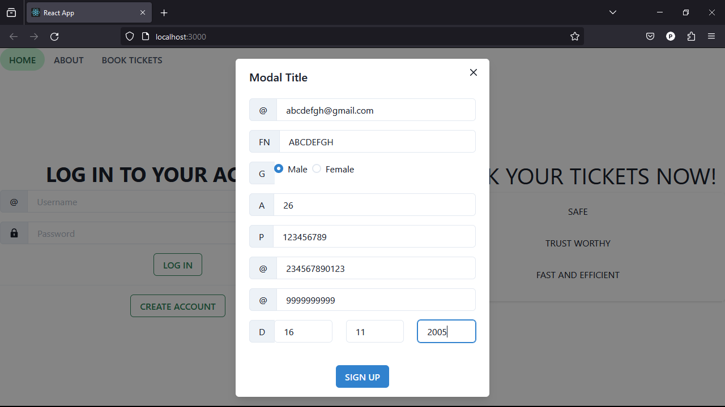

Search Flight page after logging in:-

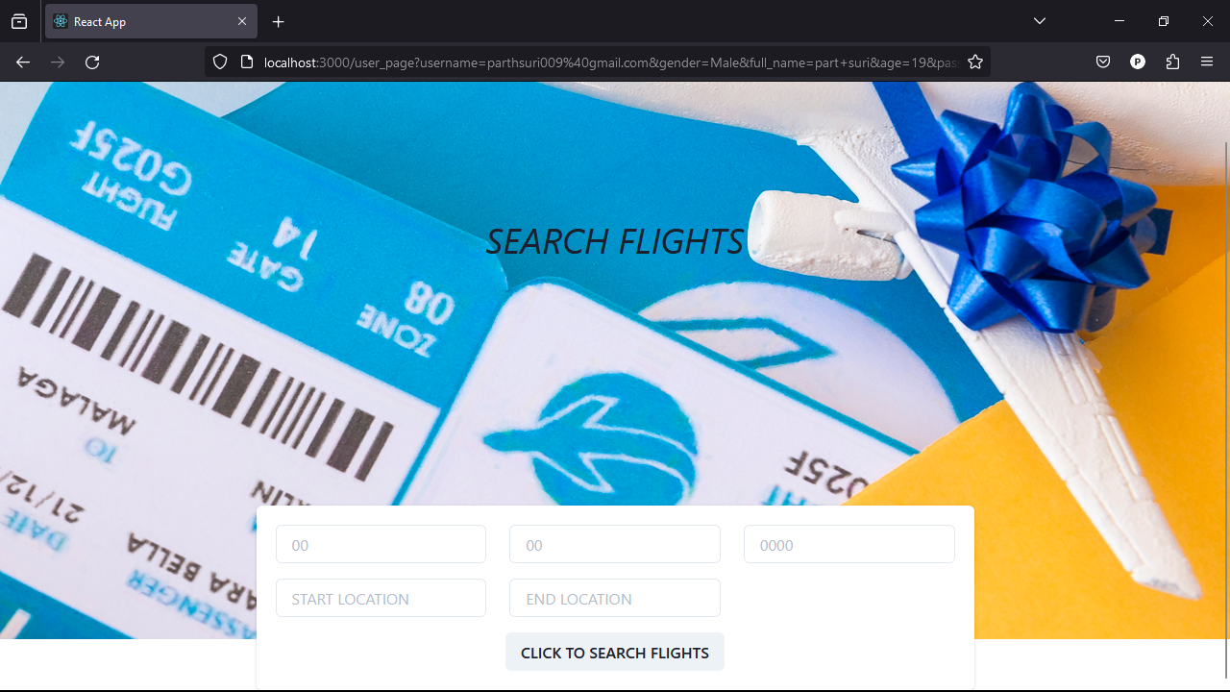

Searching for flight:-  
  
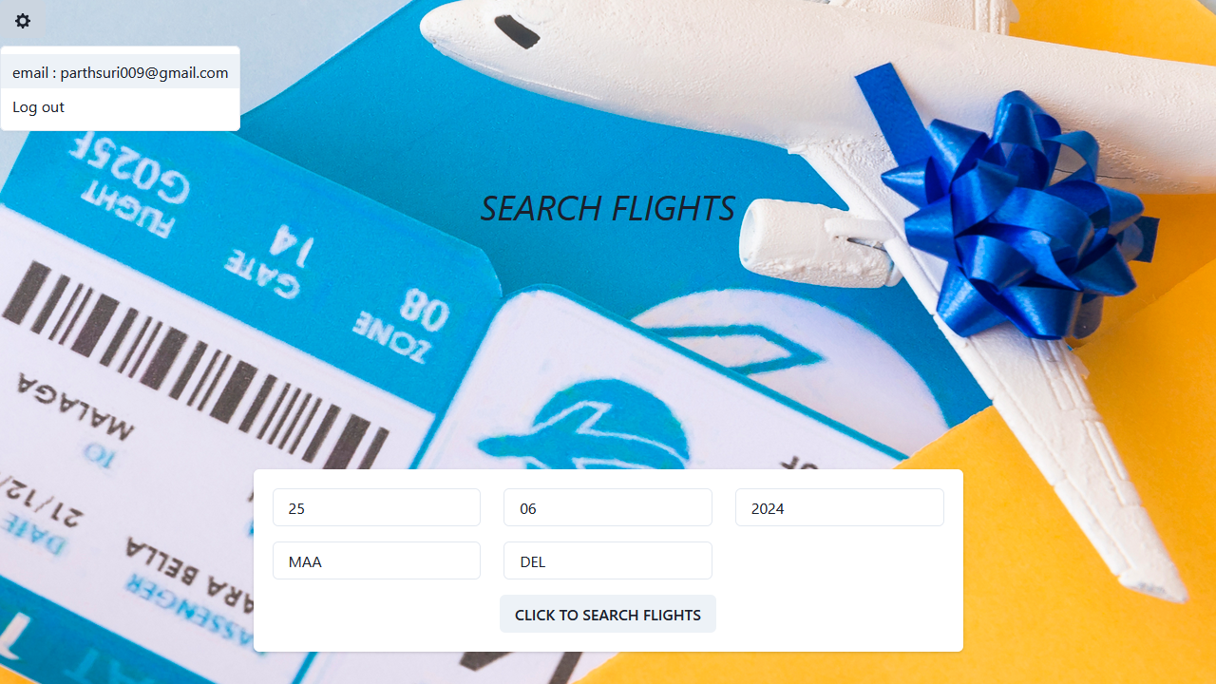

Available flights:-

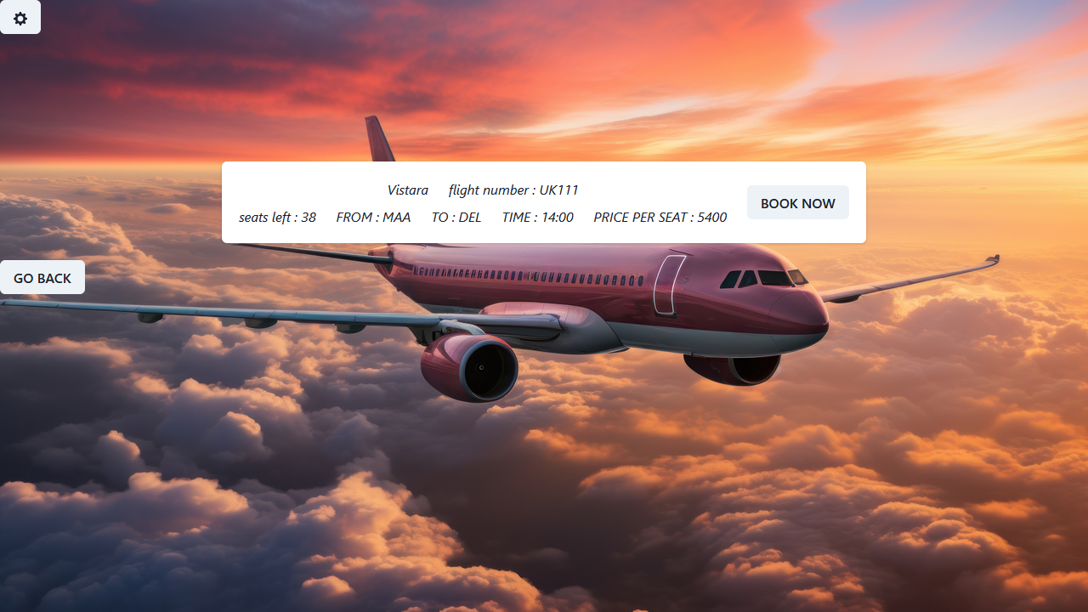

Booking Page:-  
  
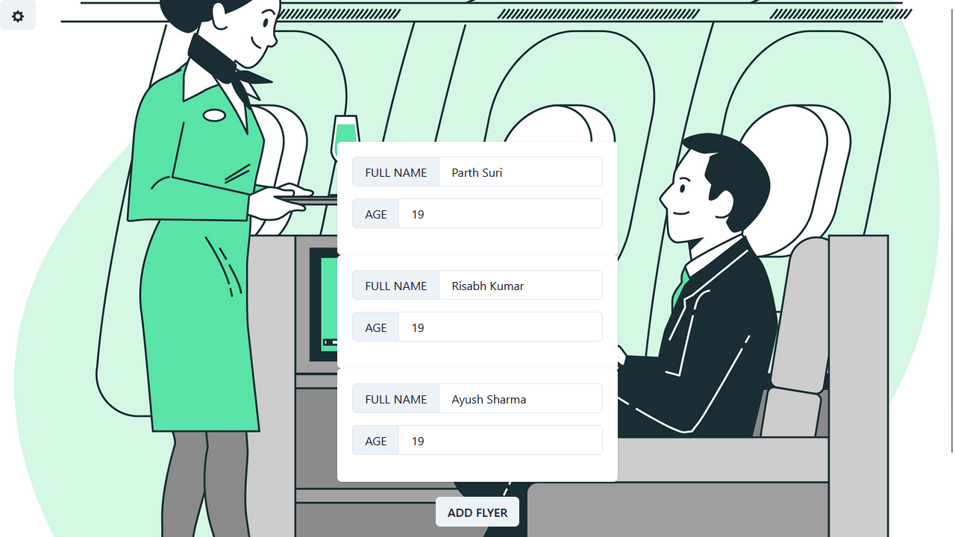

Seat Selection:-  
  
Red Indicates:- Not available  
  
Grey Indicates:- Can be booked  
  
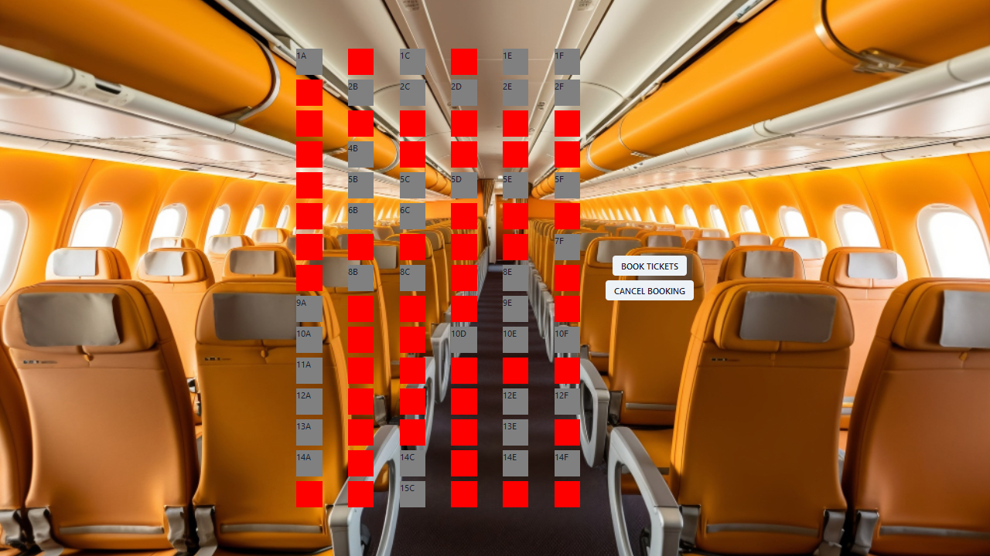

Confirmation after booking:-  
  
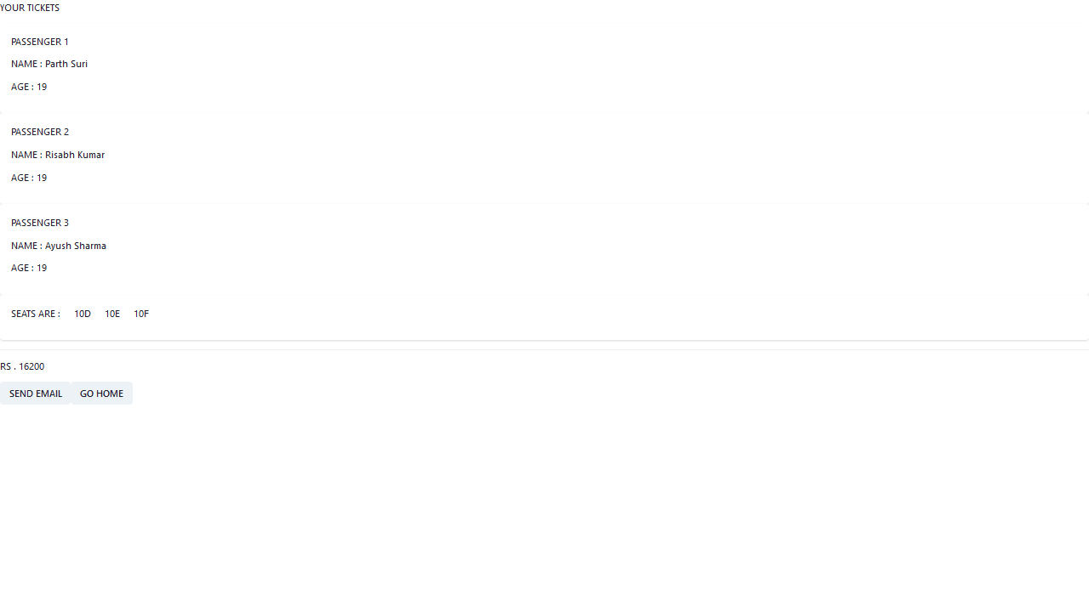

Email Confirmation:-   
  
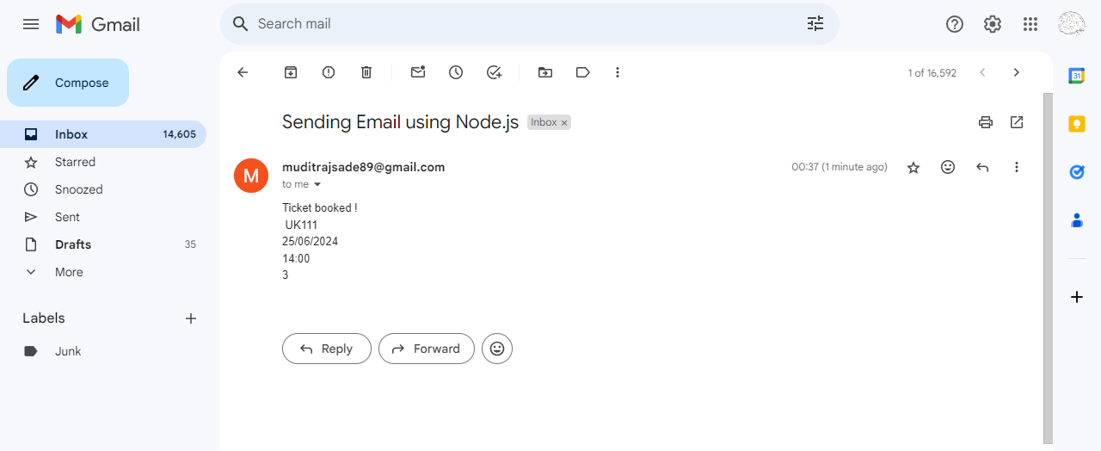

Backend developed by us is for the airlines who can add their flight details which can be visible to the customers after logging in.

**Key Directories and Files**

• **index.js**: Main server file containing the Express.js setup and API endpoints.

• **modules/**: Directory containing Mongoose models.

* user_details.js: Mongoose schema for user details.
* travel_flights.js: Presumed to contain the Mongoose schema for flight details.

**API Endpoints**  
A summary of the main API endpoints and their purposes:

• **User Management**

* POST /get_user_details: Adds a new user if the email doesn't exist.
* POST /log_in_check: Checks user login credentials.

• **Flight Management**

* POST /add_flight: Adds a new flight with seat details.
* POST /update_flight: Updates or deletes a flight based on seat availability.
* POST /get_flight_travels_current: Retrieves flights based on specified criteria.
* POST /send_mail: Sends an email confirmation for a booked flight.

**User Authentication**

* **POST /api/user/register** - Registers a new user.
* **POST /api/user/login** - Authenticates a user and returns a token.

**User Management**

**• Users are managed via Mongoose models.**

**• Endpoint /get_user_details handles user registration.**

**• Endpoint /log_in_check handles user login.Workout Plans**

**Integration with Frontend**  
The backend communicates with the frontend via RESTful APIs. Key points of integration include:

**add_flight.html**

* **Form to input flight details and generate seat layout.**
* **Uses JavaScript to handle form submission and seat selection.**
* **Submits flight details to the /add_flight endpoint.**

**Error Handling and Validation**  
• Error **Handling Strategy**

* Error responses are sent with appropriate status codes (e.g., 100 for unsuccessful operations, 200 for success).
* Try-catch blocks are used to handle errors in async functions.

• **Validation Mechanisms**

* Basic validation is performed using conditional checks.
* For example, checking if a user already exists before saving a new user.

**Security Considerations**  
• Authentication

* Authentication is handled through email and password verification.
* Passwords are stored in plain text, which is a security concern.

• **Data Encryption**

* No explicit mention of data encryption.
* For secure systems, it’s recommended to encrypt sensitive data both at rest and in transit.

• **Other Security Measures**

* **CORS**: Configured to allow all origins.
* **Database Connection**: Secure connection string is used to connect to MongoDB.